Chapter 3 Earth resources
extra worksheet 1: Temperature and humidity
Science understanding Logical /Mathematical
Name: Class: Date:
1 Use the following data to construct a graph to show how temperature and humidity vary during the day.
Time | Temperature (⁰C) | Humidity (%)
12 noon | 18.3 | 60
3.00 pm | 22.7 | 55
6.00 pm | 25.5 | 60
9.00 pm | 21.1 | 85
12 midnight | 13.8 | 100
3.00 am | 12.7 | 100
6.00 am | 10.0 | 100
9.00 am | 15.0 | 78
12 noon | 21.1 | 59
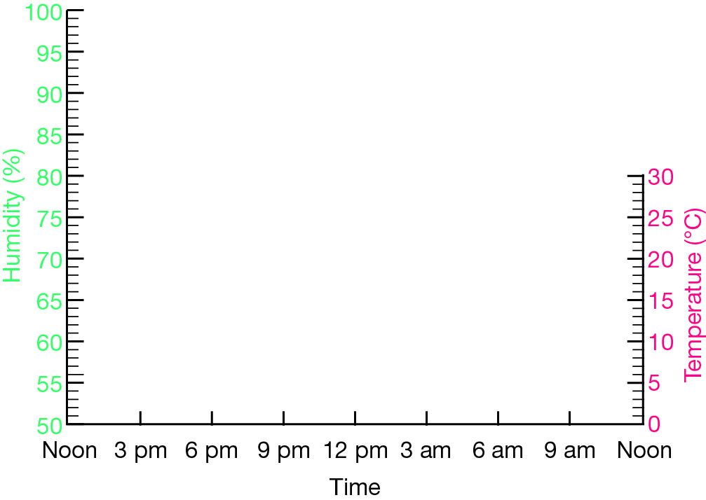
2 Use the graph you have constructed to describe the relationship between temperature and humidity.

3 a Propose the time of day at which evaporation rates would be lowest.

b Justify your response.

4 a As sweat evaporates from your skin you body becomes cooler. On three days the humidity at 12 noon was 60%, 65% and 80%. Select the day on which you would feel most uncomfortably hot.

b Justify your response.

